Lab 1: Setup Environment
- Eclipse
- Visual Studio Code
  - Download Link: https://code.visualstudio.com/
  - Once it is installed, also install the following extensions:
    - Azure Account from Microsoft
    - Azure Functions from Microsoft
    - Azure Resources from Microsoft
- Java 17
  - Download Link: https://www.oracle.com/java/technologies/javase/jdk17-archive-downloads.html
  - Once it is installed, confirm it by running ‘java –version’ command in command prompt.
- Maven 3.9.2
- SQL Server Management Studio
  - Download Link: https://aka.ms/ssmsfullsetup
- Nodejs (18.14.0 used for following labs)
  - Download link: https://nodejs.org/en/download
- Azure CLI
  - Download link: https://learn.microsoft.com/en-us/cli/azure/install-azure-cli-windows?tabs=azure-cli

Lab 2: Create Azure SQL Database
- Go to Azure Portal and login into it.
- Search for ‘SQL Database’ and click on SQL Databases
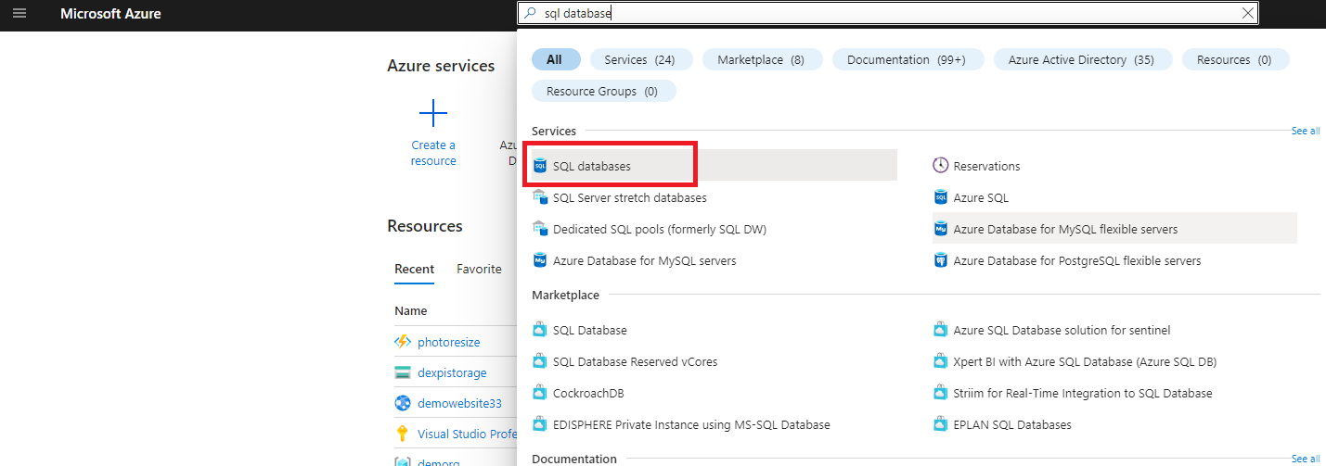
- Click on Create
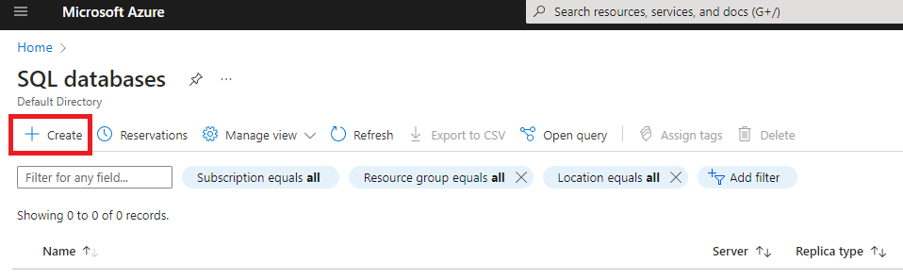
- Fill in the following details
  - For Subscription, select your subscription in which you want to create the SQL Database
  - For Resource Group, click on ‘Create new’
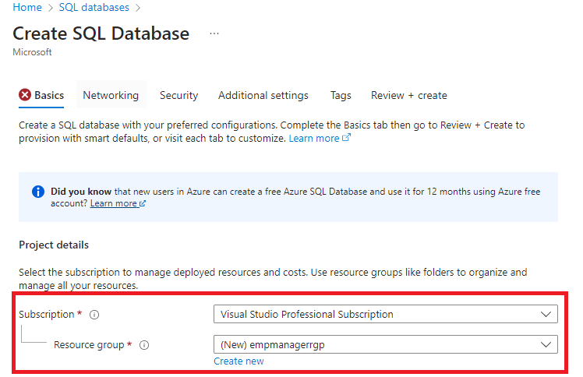
  - Give a name for the resource group.
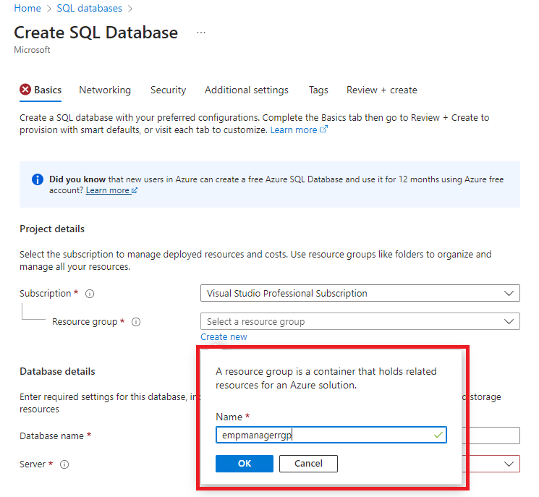
  - Give a name for the database
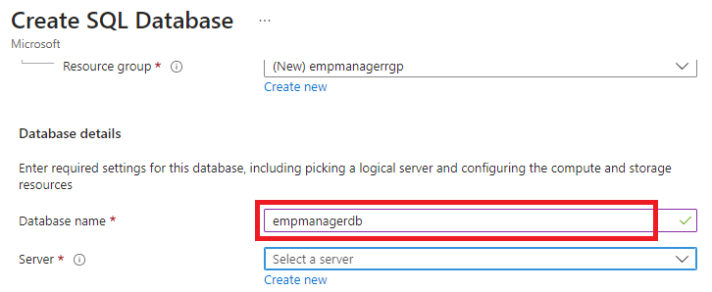
  - For Server, click on ‘Create new’
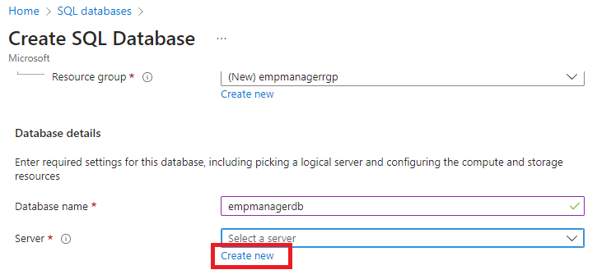
  - Provide name for SQL Server
  - For Location, select the one which you would like to deploy the SQL Server.
  - For Authentication Method select, ‘Use SQL Authentication’
  - Click on OK when all the details for SQL Server are provided
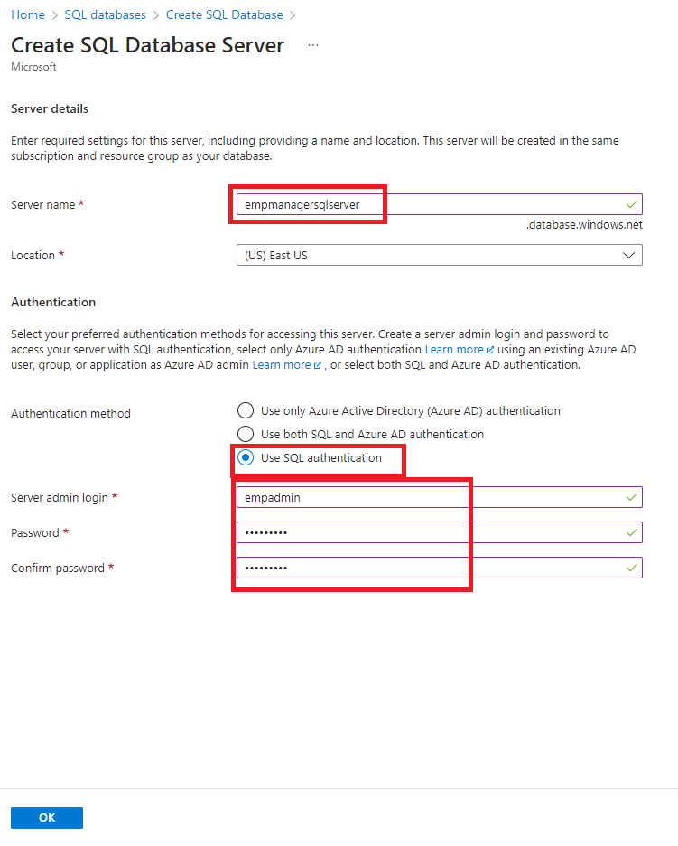
  - For Workload environment, select ‘Production’
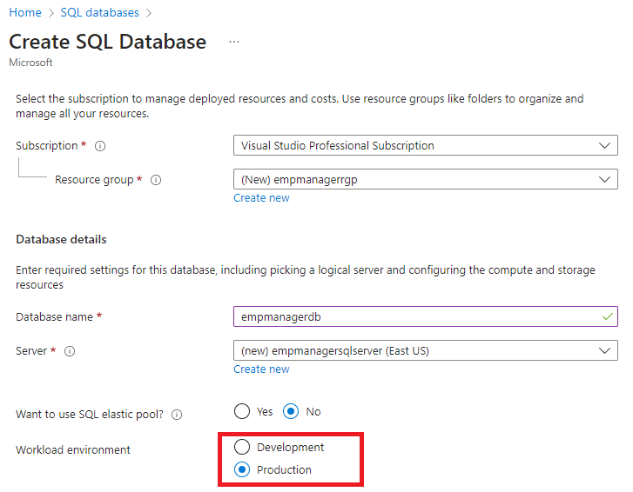
  - For Compute + Storage, click on ‘Configure database’
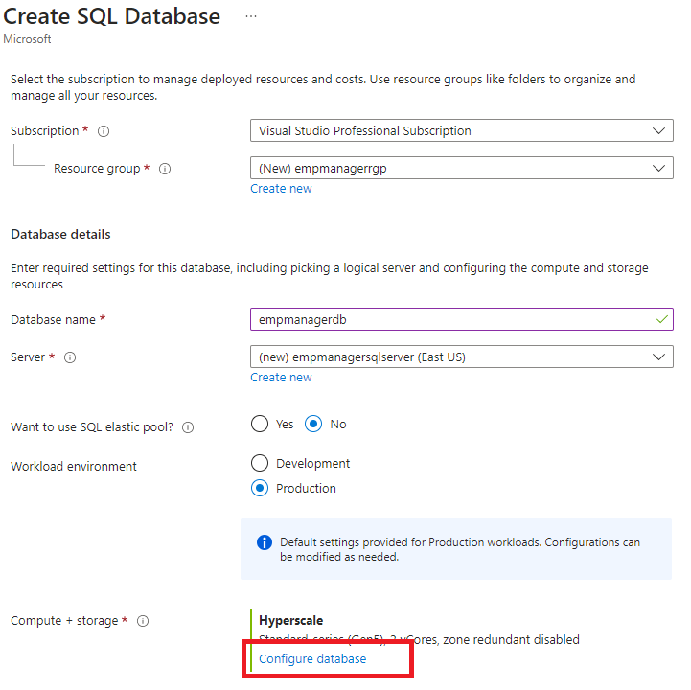
  - For Service tier, select ‘Basic’ under DTU-based purchasing model
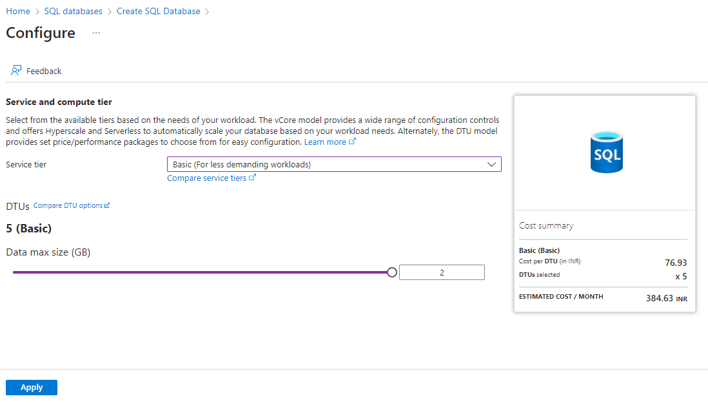
  - Click on Apply
  - For Backup storage redundancy, select ‘Locally-redundant backup storage’
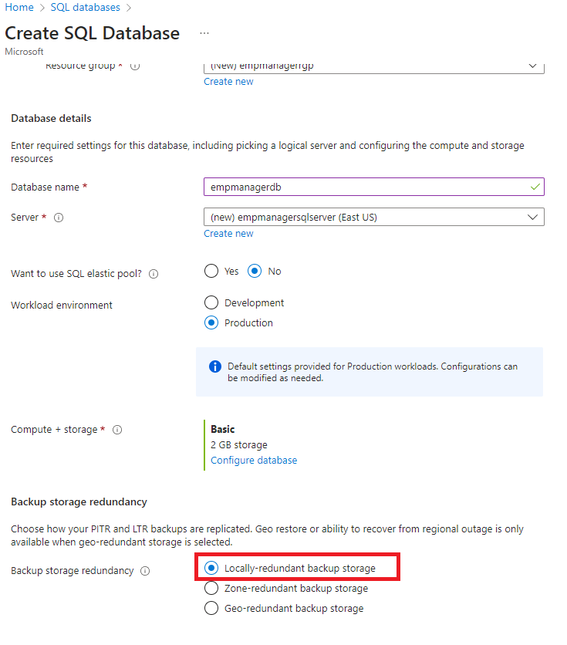
  - Click on ‘Next: Review + create’
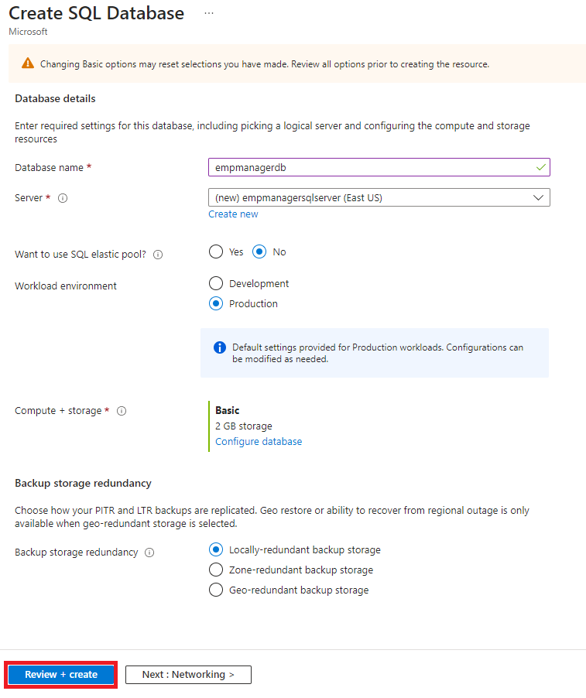
  - Review the details and then click on ‘Create’
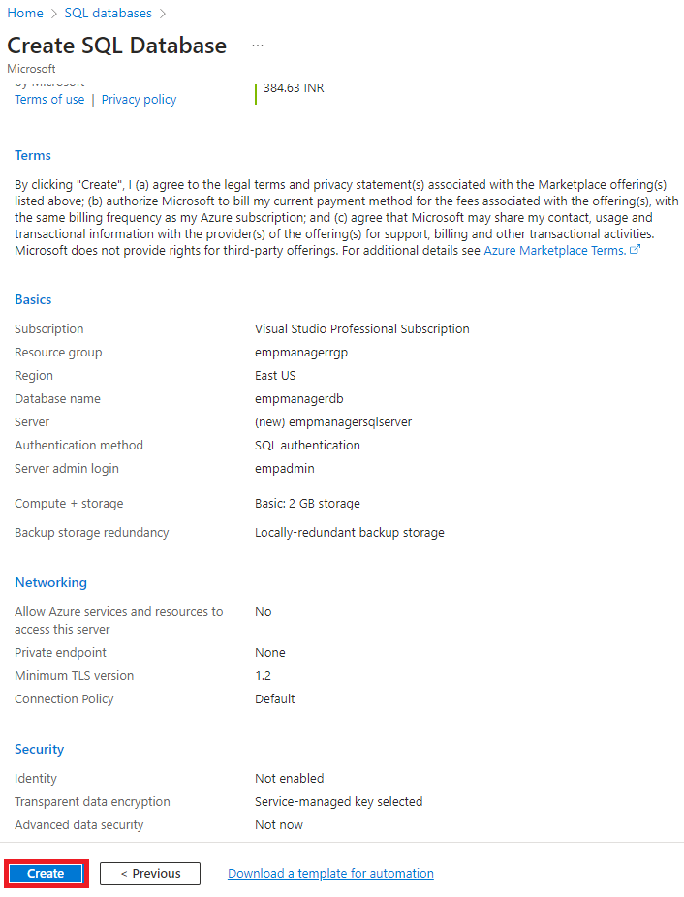
- Once the SQL Database is created, go to its Overview.
- Click on the ‘Set server firewall’
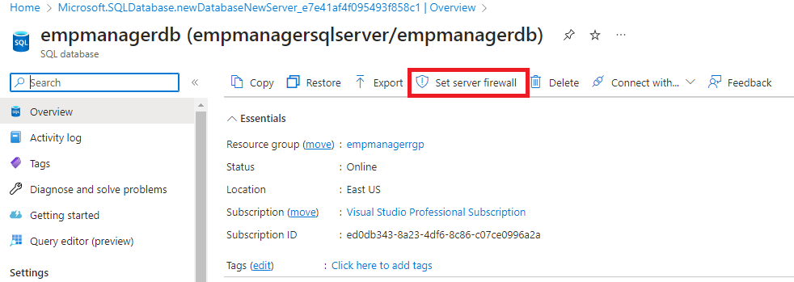
- Select ‘Selected networks’ under Public access
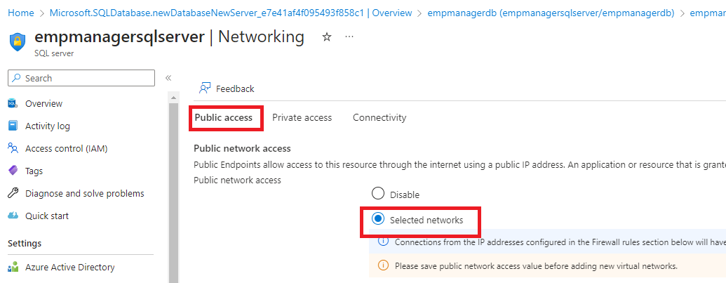
- Under Firewall rules, click on ‘Add your client IPv4 address’
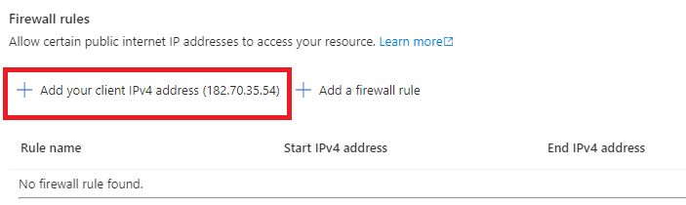
- Click on Save.
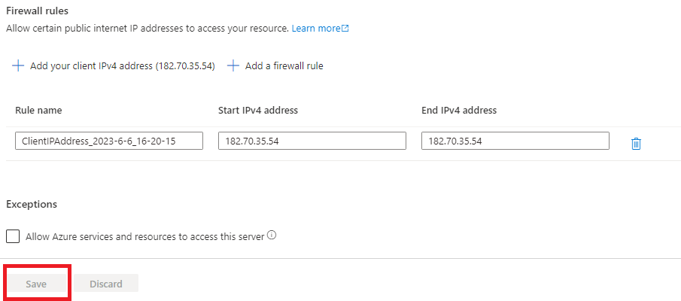
- Go back to SQL Database overview, and click on Connection Strings
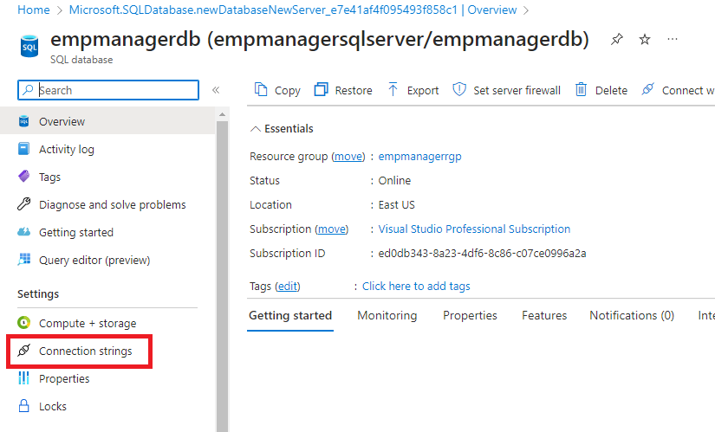
- Click on JDBC and copy the connection string.
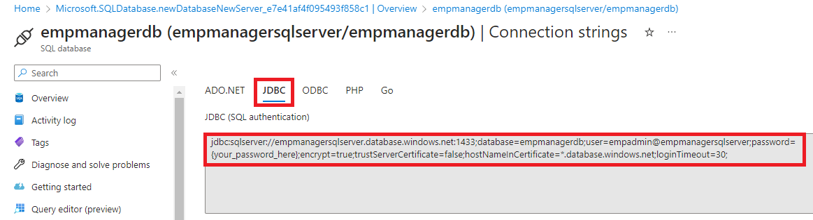
- On your local machine, open SQL Server Management Studio.
- To connect to the Azure SQL Database, copy the Server name from the Overview page of the SQL Database.
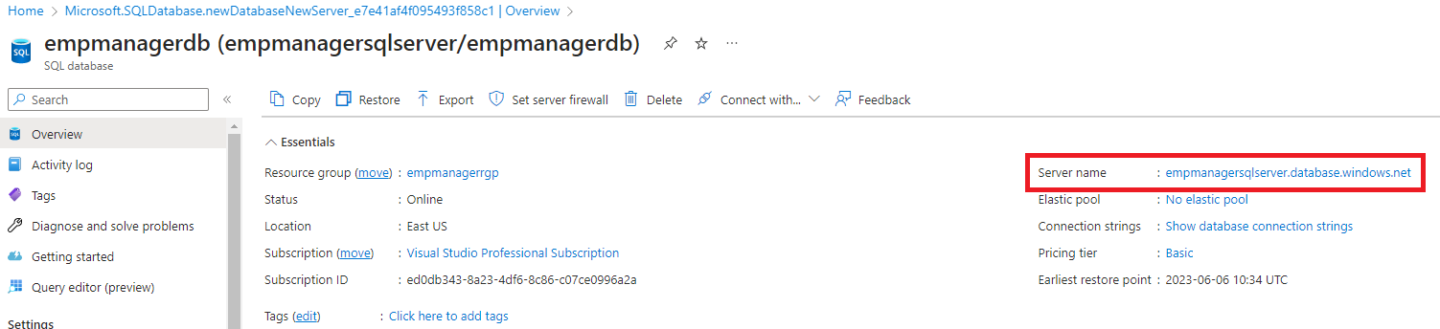
- Provide the server name as Server name and provide your user and password which was provided while creating the SQL Database.
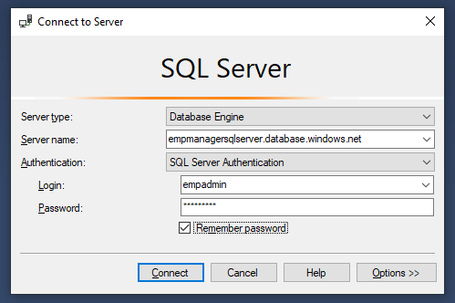
- In Object Explorer, you could now manage your database
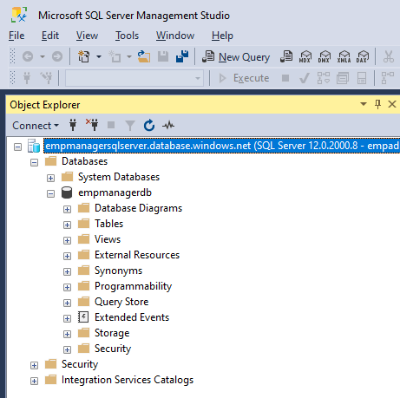

Lab 3: Create Storage Account
- Go to Azure Portal, and login into it.
- Search for Storage Accounts, and click on Storage accounts
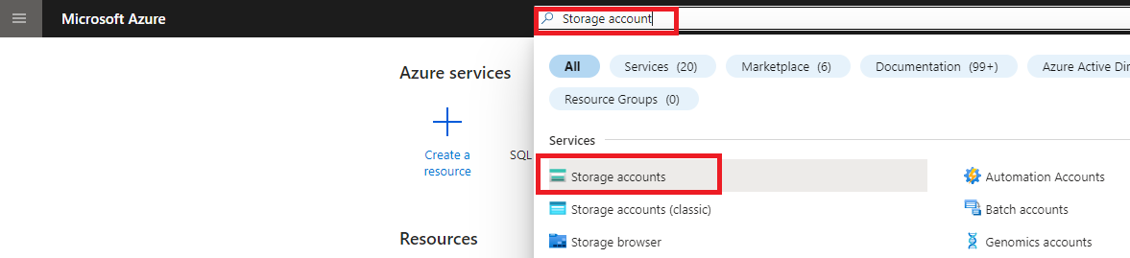
- Click on ‘Create’
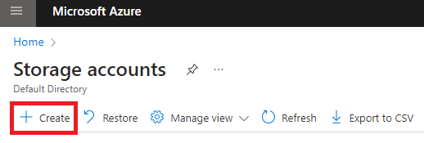
- Fill in the following details:
  - For Subscription and resource group, select the same as selected for when creating Azure SQL Database in previous lab.
  - Give a name for Storage account name.
  - Select ‘Standard’ for performance
  - For Redundancy, select Locally-redundant storage (LRS)
  - Click on ‘Review’ after providing all the details
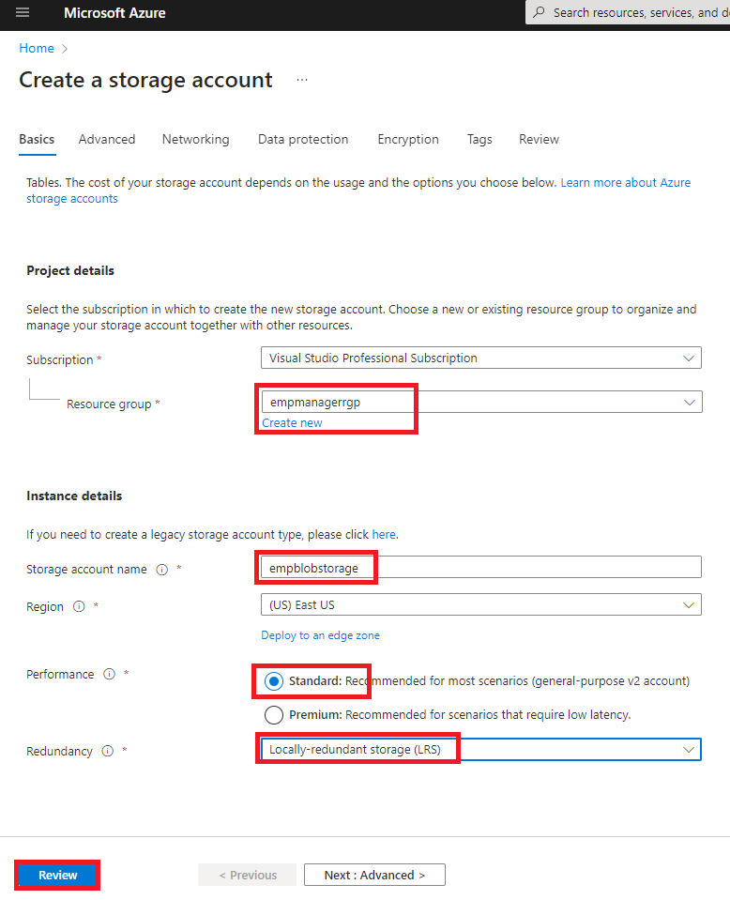
  - Review the details and then click on ‘Create’.
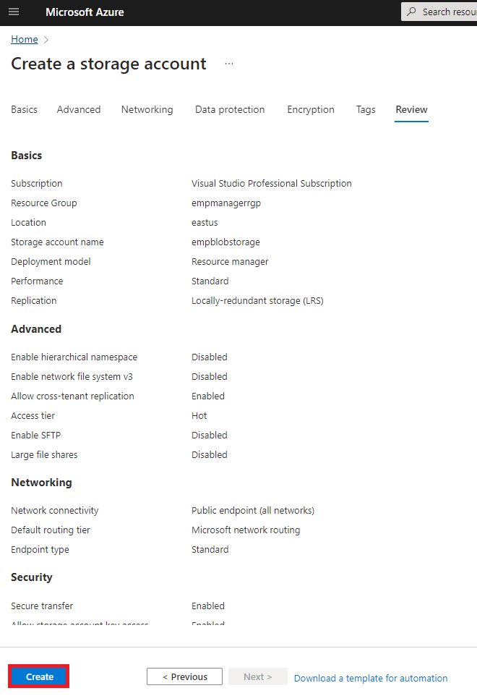

- Once the Storage account is created, go to its Overview page.
- Click on ‘Access Keys’
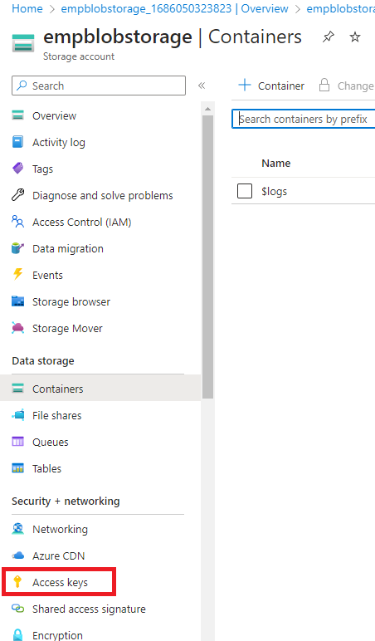
- Copy the connection string
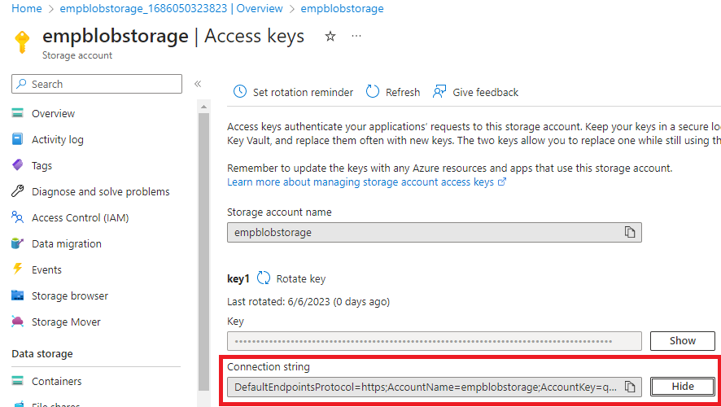

Lab 4: Run the Employee Manager Application
- Download the Employee backend springboot project using this link and unzip it
- https://aztrgstr.blob.core.windows.net/az-java-training/EmployeeManagerBackend.zip
- Open the application in Eclipse
- Open application.properties file and add the database and storage connection string as shown below
  - Add the Azure SQL Database JDBC connection string for the property named ‘spring.datasource.url’. Replace the password in the connection string before adding it.
  - Add the Azure Storage account connection string for the property named ‘azure.storage.connectionstring’.
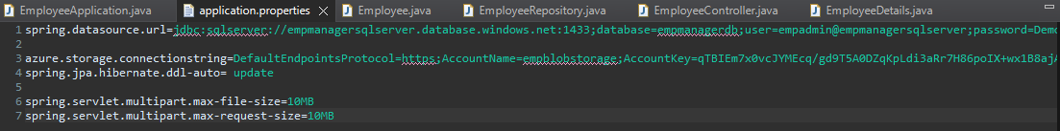
- Build the project
- Run the project. Swagger url for the backend: http://localhost:8080/swagger-ui/index.html
- Download the Employee frontend react application using this link and unzip it.
- Open the Command prompt and go to the frontend react project path
- Run ‘npm install’
- Run ‘npm start’
- Go to http://localhost:3000
- You should now be able to create, view and delete the employee information.
- The employee details would be stored in Azure SQL Database and the profile photo of the employee would be stored in Azure Storage Account in a blob container.
- The photo of the employee is currently not shown in the home page as it not available right now. We would be implementing an Azure function which would resize the actual profile picture into a smaller size, which would be then displayed in home page.
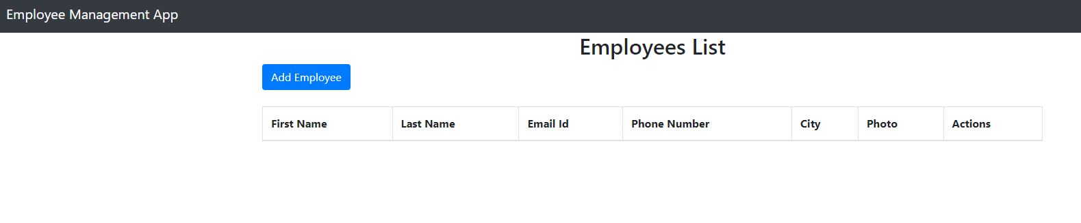
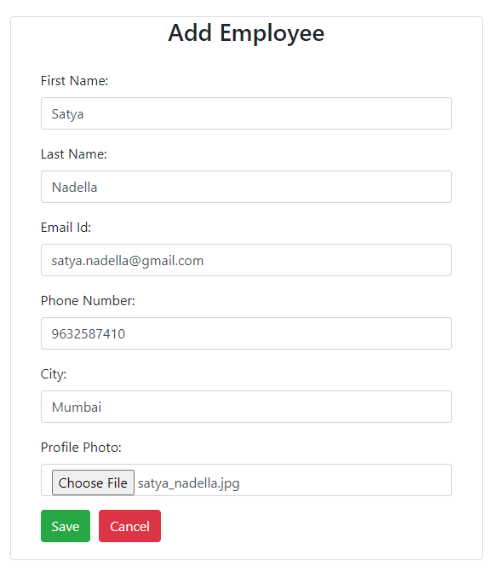
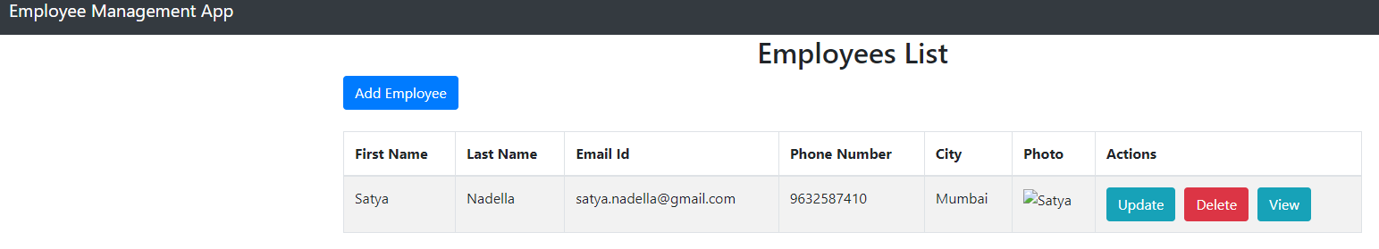
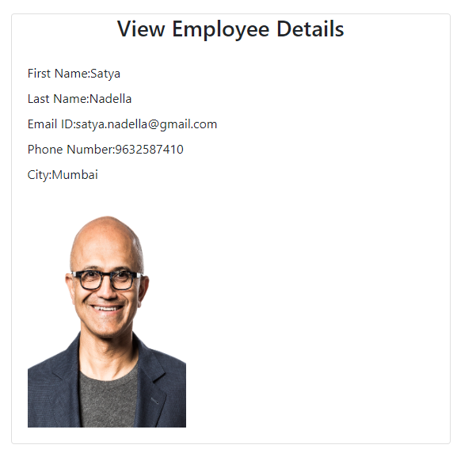

Lab 5: Use Azure Functions to resize Employee profile photo
- In this lab, we are going to resize the employee profile photo which is stored Azure Storage account under blob container named ‘photos’. We would create an Azure function which would be triggered when an employee photo is added to ‘photos’ blob container. It would read the photo and resize it and store it in another blob container.
- Go to Azure Portal, and login into it.
- Search for ‘function’, and click on Function App.
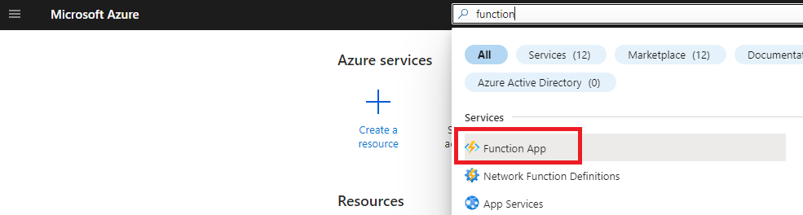
- Click on ‘Create’
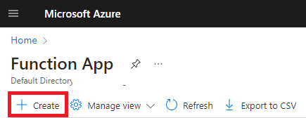
- Fill in the following details:
  - For Subscription and resource group, select the same subscription and resource group which you have selected for previous labs for creating SQL Database and Storage account.
  - Provide a name for the function app.
  - Select ‘Code’ for ‘Do you want to deploy code or container image?’
  - Select ‘Java’ for Runtime stack
  - Select ’17.0’ for Version
  - Select ‘Windows’ for Operating System
  - Select ‘Consumption (Serverless)’ for Hosting options and plans
  - Click on ‘Next: Storage’ when all the details are filled.
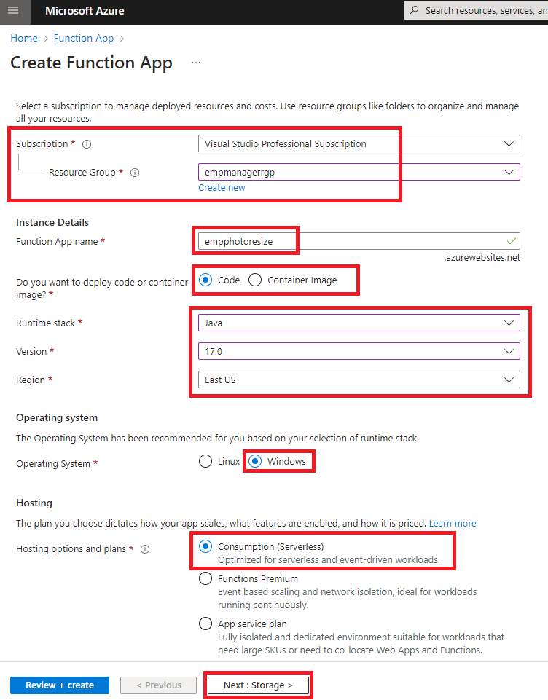
  - In Storage tab, select the storage account which you created in previous lab.
  - Click on ‘Review + create’
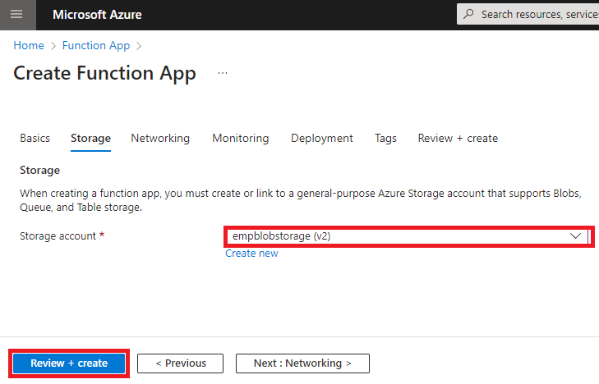
  - Review all the details and click on ‘Create’
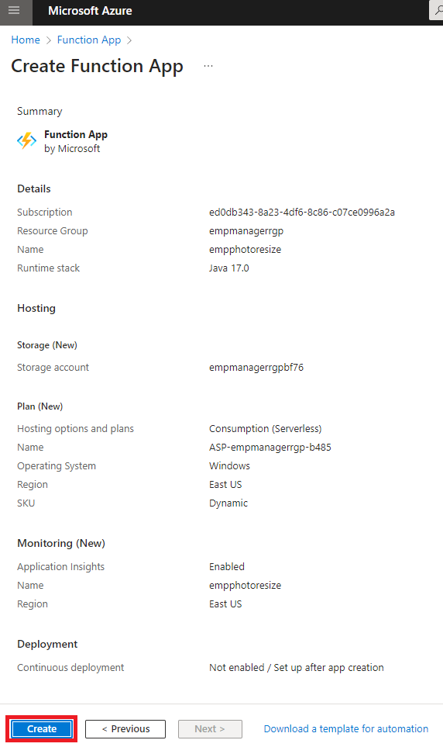
- Open Visual Studio Code and install Azure Functions extensions.
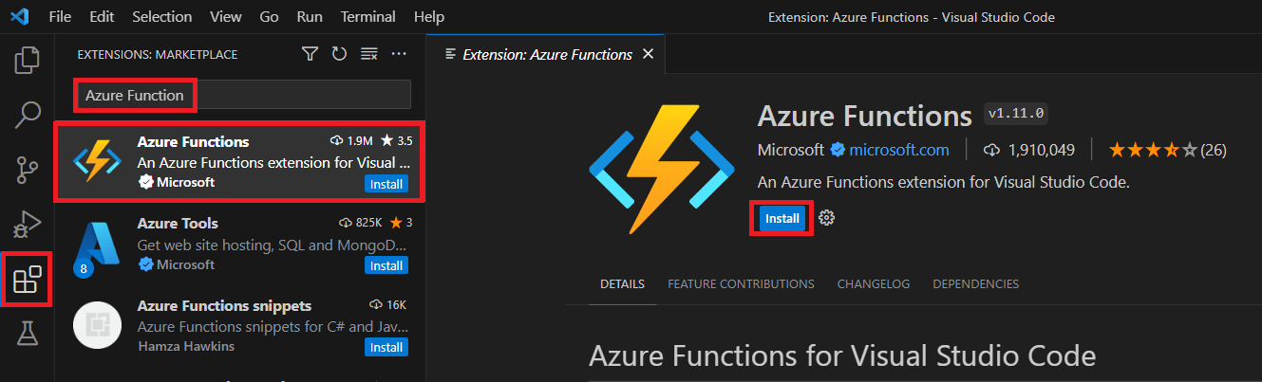
- Once the extension is installed, click on the Azure Extension.
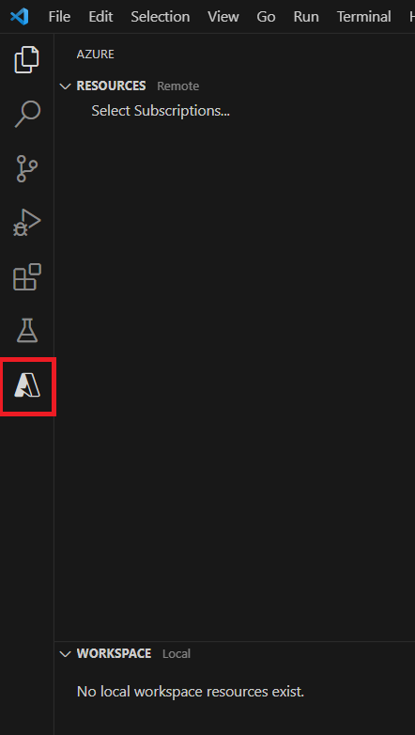
- Click on ‘Sign in to Azure’.
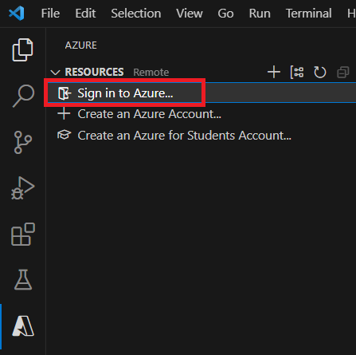
- Once you are signed in, click on ‘Select Subscriptions’ and select your subscription
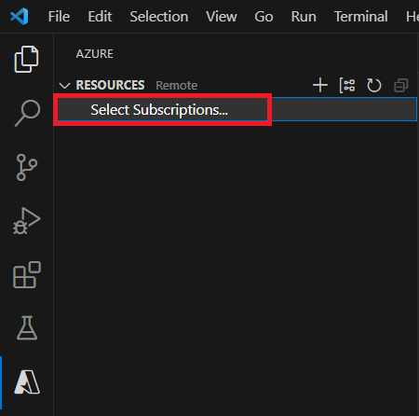
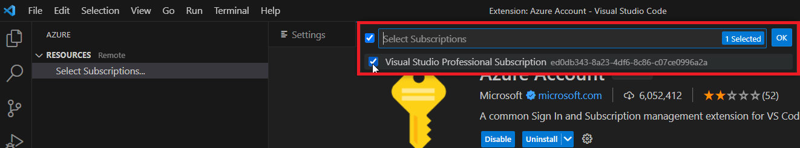
- Click on Create Function.
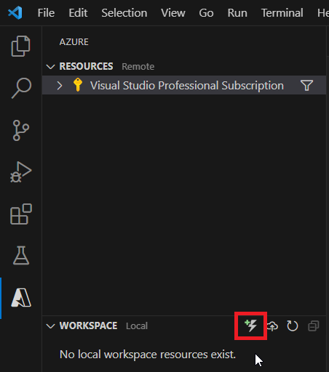
- Select a folder to for your function code.
- Select Java for programming language.
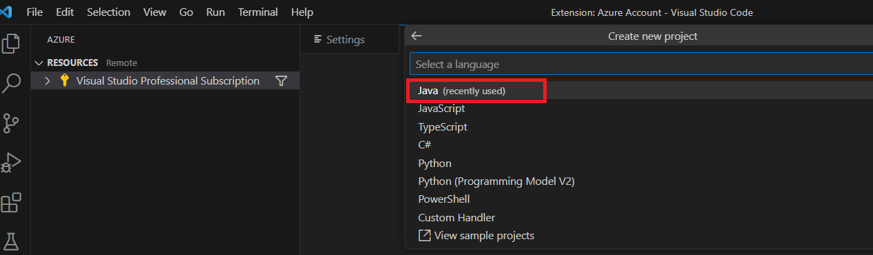
- Select Java 17 for version
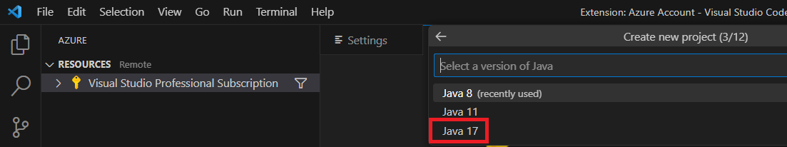
- Provide group id for the project.
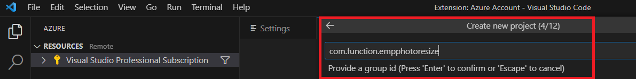
- Provide artifact id for the project.
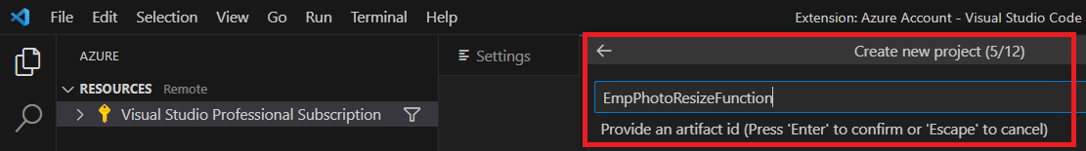
- Provide version for the project
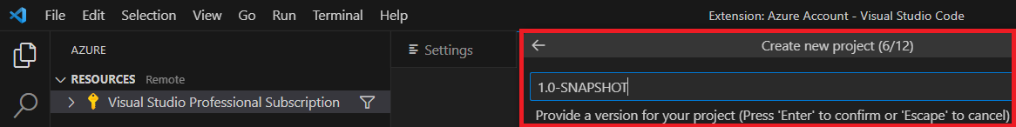
- Provide package name for the project
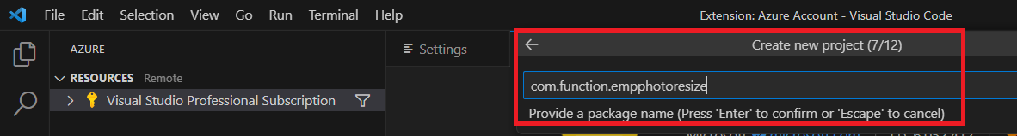
- Keep default app name and press enter
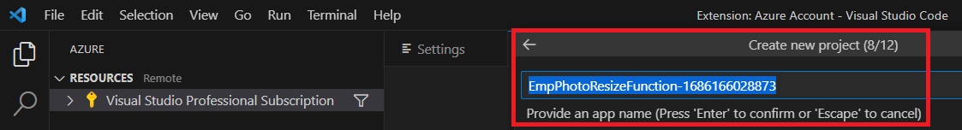
- Select Maven for build tool
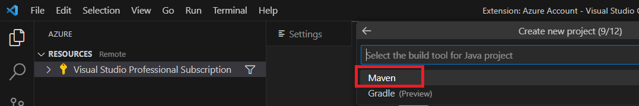
- Select ‘Open in current window’ for ‘Select how you would like to open your project’
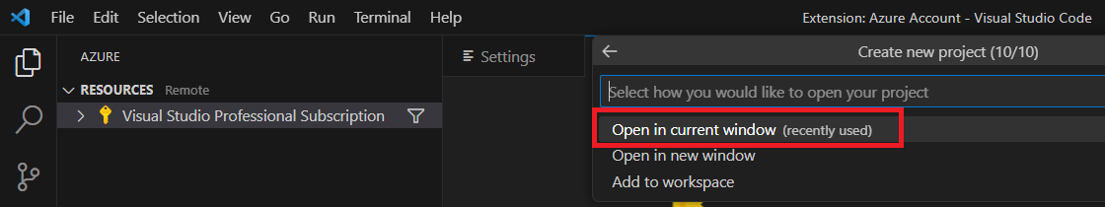
- By default, created function is a HttpTrigger, but we want a BlobTrigger which would trigger the function when we add an employee profile photo to the blob container named ‘photos’.
- Open Function.java file, replace the imports with the following imports:
import com.microsoft.azure.functions.annotation.*;
import java.awt.Graphics2D;
import java.awt.image.BufferedImage;
import com.microsoft.azure.functions.*;
import java.io.ByteArrayInputStream;
import java.io.ByteArrayOutputStream;
import java.io.IOException;
import javax.imageio.ImageIO;

- Replace the whole run method with below code:
@FunctionName("HttpExample")
@StorageAccount("AzureWebJobsStorage")
public void run(
@BlobTrigger(name = "content", path = "photos/{name}", dataType = "binary") byte[] content,
@BindingName("name") String fileName,
@BlobInput(name = "inputBlob", path = "photos/{name}", dataType = "binary") byte[] inputBlob,
@BlobOutput(name = "outputBlob", path = "test-output-java/{name}", dataType = "binary") OutputBinding<byte[]> outputBlob,
final ExecutionContext context
) throws Exception {
ByteArrayInputStream inputFile = new ByteArrayInputStream(inputBlob);
BufferedImage inputImage;
try {
inputImage = ImageIO.read(inputFile);

// creates output image
BufferedImage outputImage = new BufferedImage(50,
50, inputImage.getType());

// scales the input image to the output image
Graphics2D g2d = outputImage.createGraphics();
g2d.drawImage(inputImage, 0, 0, 70, 70, null);
g2d.dispose();

ByteArrayOutputStream outputStream = new ByteArrayOutputStream();
// writes to output file
ImageIO.write(outputImage, "jpg", outputStream);
byte[] photoIcon = outputStream.toByteArray();
outputBlob.setValue(photoIcon);
} catch (IOException e) {
// TODO Auto-generated catch block
e.printStackTrace();
}
}

- Delete the test folder for now.
- Build the project by clicking on Run build task to update the list to create the package which will be deployed to Function App.
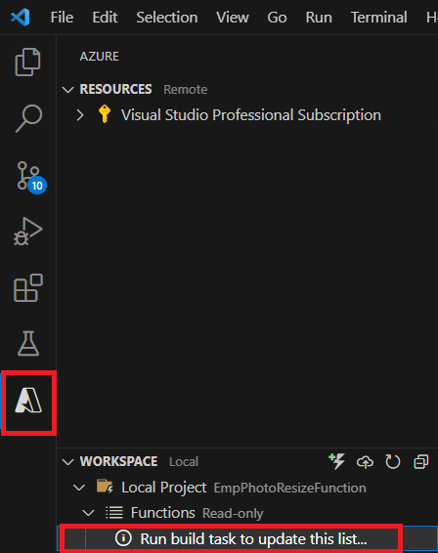

- Once the build is completed, click on Deploy
https://aztrgstr.blob.core.windows.net/az-java-training/EmpPhotoResizeFunction.zip

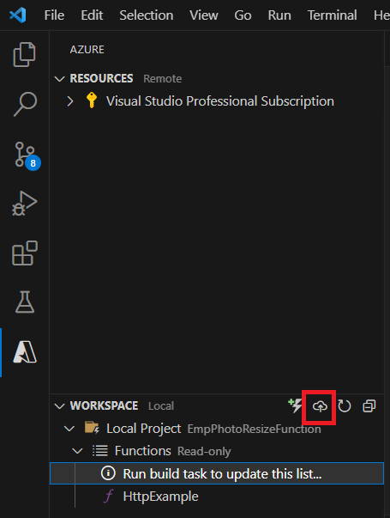
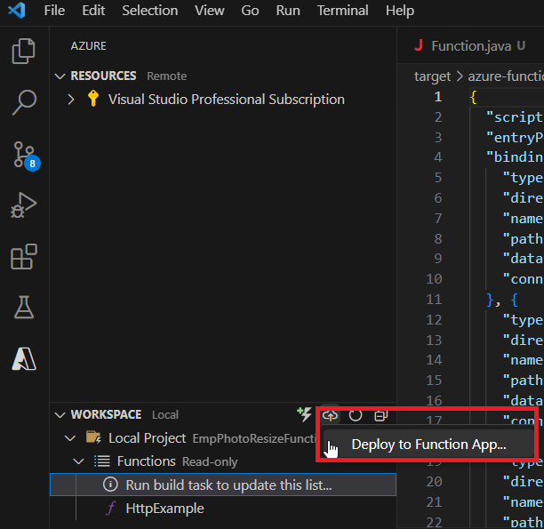
- Select the Function app to be deployed to for resource
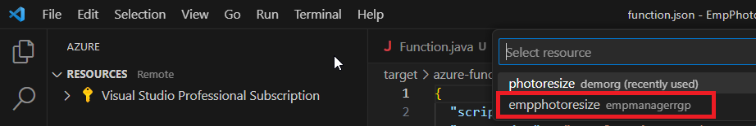
- Confirm the deployment.
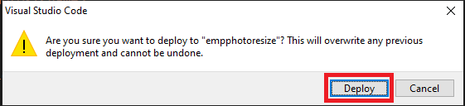
- Once the deployment is completed, reload the employee manager front end application after few minutes. It will now load the resized profile photo of the employees. Everytime a new employee is added, the function is triggered and the new employee photo is resized and uploaded to output blob container.
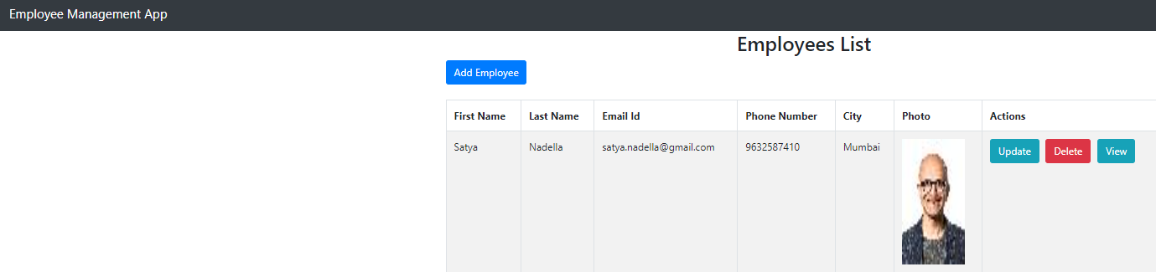
- You can find the resized photo in the test-output-java container.
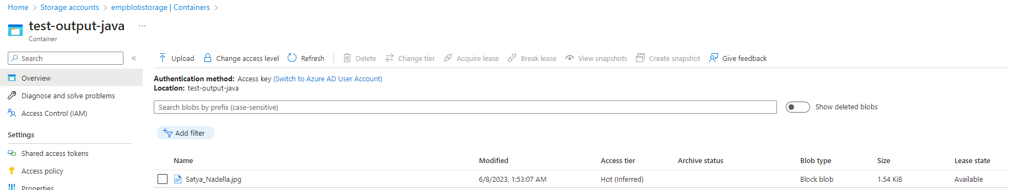

Lab 6: Use Azure Logic Apps and Azure Service Bus Queue to send welcome mail to the new employee
- In this lab, we would be using Azure Logic Apps to send a welcome mail to the new employee. We would first create a Service Bus Queue, where we would queue a new message whenever we create a new employee in the backend application. This queue message would then trigger the Logic App which would then send a mail to the employee mail id as provided in the queue message.
- Go to Azure Portal, and login into it.
- Search for Azure Service Bus and click on Service Bus.
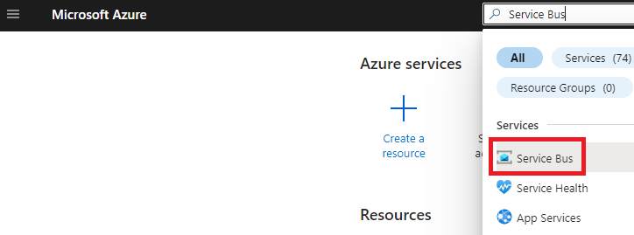
- Click on ‘Create’
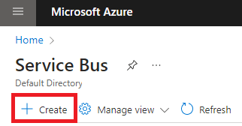
- Provide the following details:
  - For Subscription and Resource group, select the same as selected in previous labs
  - Provide a unique namespace.
  - For Pricing tier, select ‘Basic’
  - Click on ‘Review + create’ once all the above details are provided.
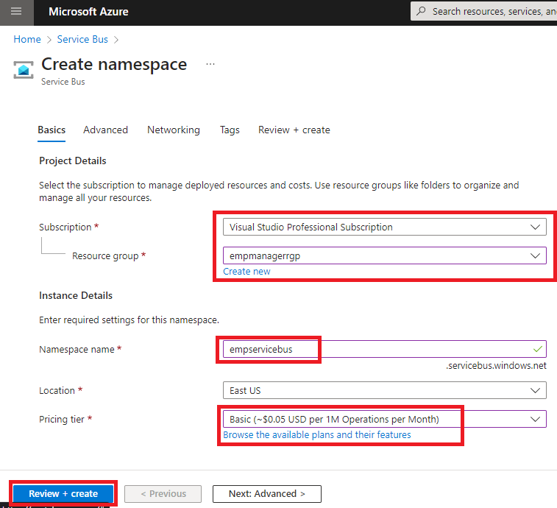
  - Review all the details and click on ‘Create’
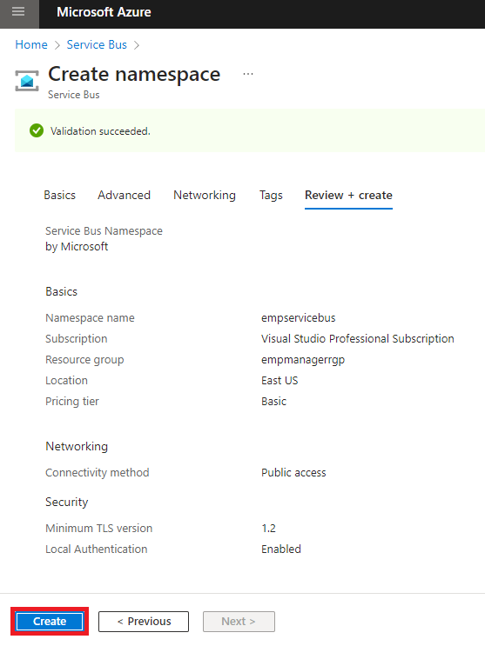
- Once the Service Bus is created, go to is Overview.
- Click on ‘+Queue’
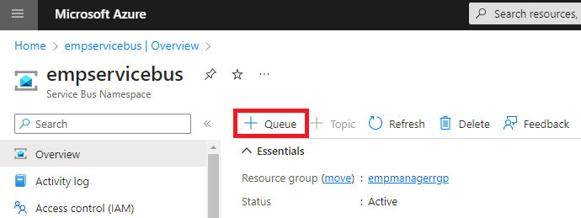
- Provide a name for the queue.
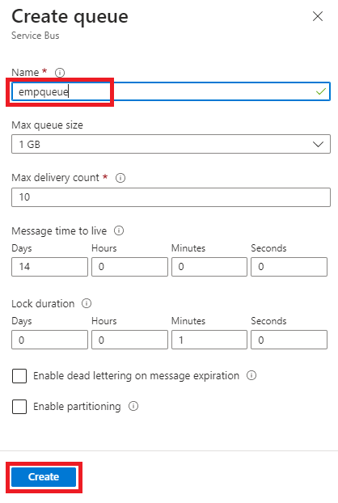
- Keep default value for other properties.
- Click on Create.
- Click on ‘Shared access policies’.
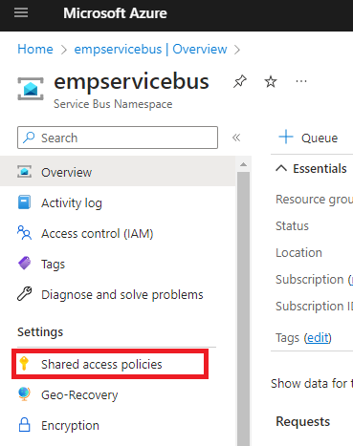
- Click on ‘RootManageSharedAccessKey’ policy.
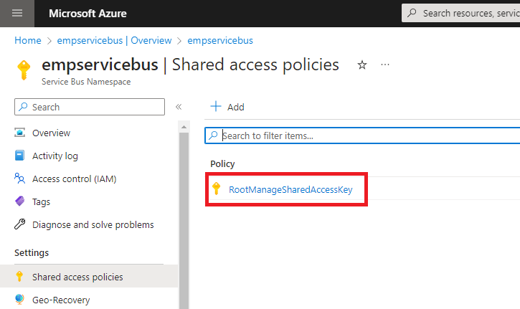
- Copy the Primary Connection String
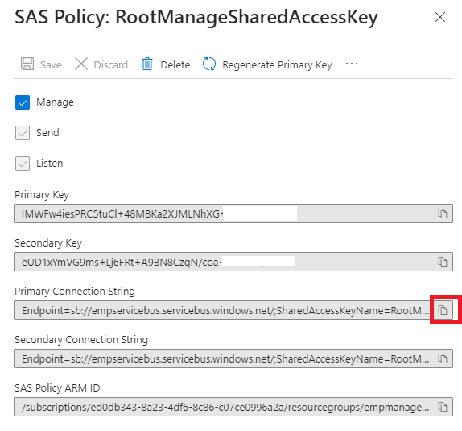
- Now go to the Employee Backend application.
- Add the following dependency in the pom.xml file
<dependency>
<groupId>com.azure</groupId>
<artifactId>azure-messaging-servicebus</artifactId>
<version>7.13.3</version>
</dependency>
- In application.properties file, add the below new property
  - azure.servicebus.connectionstring: <Paste the PrimaryConnectionString which you copied in previous step>
  - azure.servicebus.queuename: <Paste the queue name which you created in previous step>
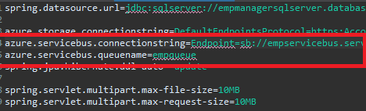

- Open EmployeeController.class file, and add the following imports
import com.azure.messaging.servicebus.ServiceBusClientBuilder;
import com.azure.messaging.servicebus.ServiceBusMessage;
import com.azure.messaging.servicebus.ServiceBusSenderClient;

- Add the following two properties in EmployeeController class

@Value("${azure.servicebus.connectionstring}")
private String serviceBusConnectionString;

@Value("${azure.servicebus.queuename}")
private String serviceBusQueueName;

- In the createEmployee method, replace the ‘return employeeRepository.save(employeeDetails)’ line of code with below code
Employee savedEmployee = employeeRepository.save(employeeDetails);
// create a Service Bus Sender client for the queue
ServiceBusSenderClient senderClient = new ServiceBusClientBuilder()
.connectionString(serviceBusConnectionString)
.sender()
.queueName(serviceBusQueueName)
.buildClient();

// send one message to the queue
senderClient.sendMessage(new ServiceBusMessage(employeeDetails.getEmailId()));

return savedEmployee;

- Build the project and run it.
- Add a new employee with a valid email address using the frontend application or swagger.
- Go to Azure Portal, and search for Logic App, and click on Logic apps
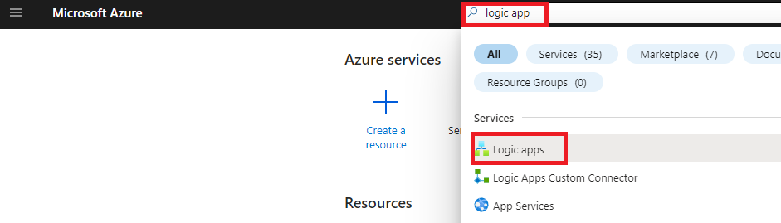
- Click on ‘+Add’
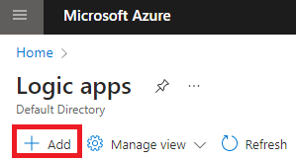
- Provide the following details:
  - For Subscription and resource group, select the same as selected for previous labs.
  - Provide a name for logic app.
  - Select ‘No’ for Enable log analytics
  - Select ‘Consumption’ for Plan type
  - Select ‘Disabled’ for Zone redundancy
  - Click on ‘Review + create’ once the above details are provided.
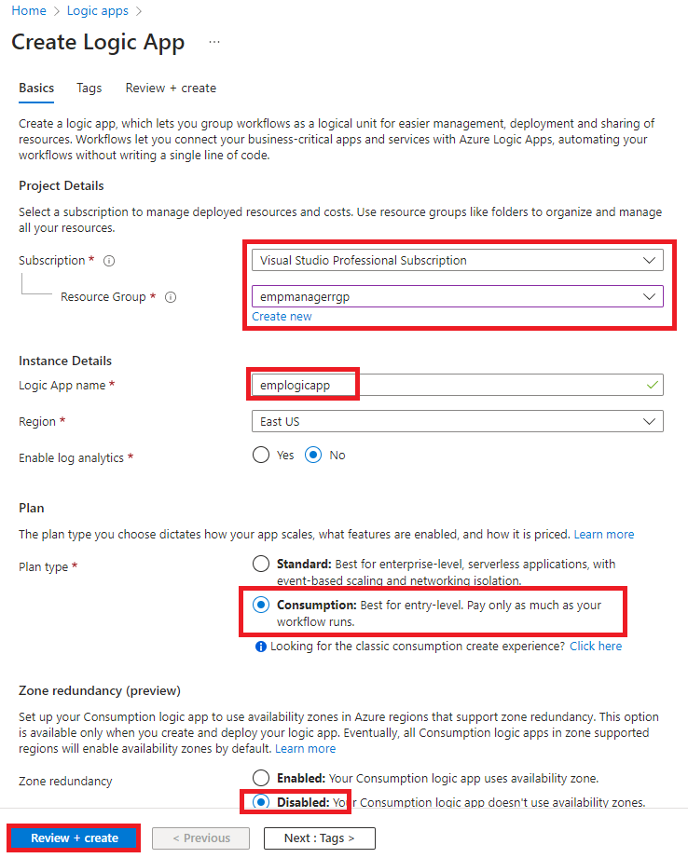
  - Review all the details and click on ‘Create’
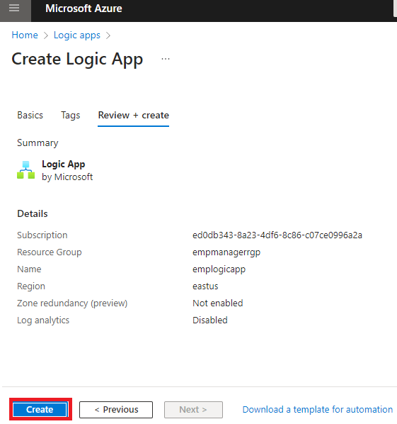
- Once the logic app is created, go to the resource
- Click on ‘When a message is received in a Service Bus queue’ trigger
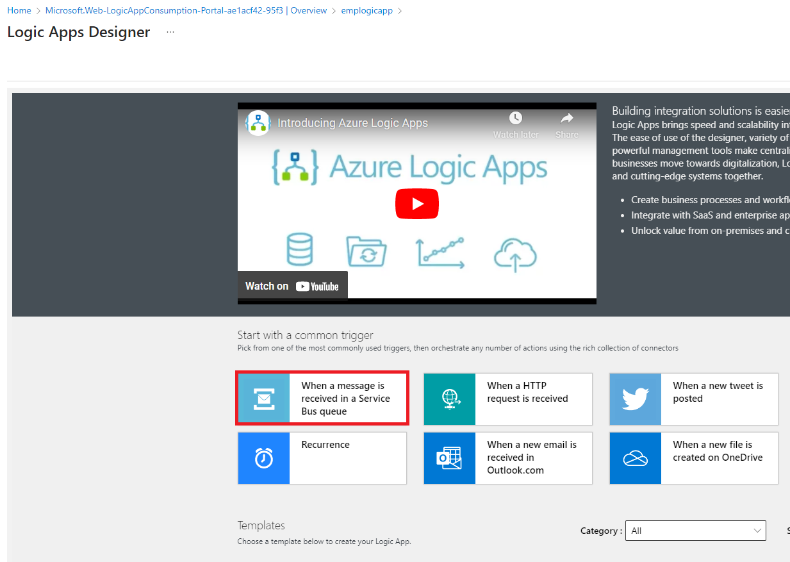
- In the Logic apps designer, click on ‘Sign in’
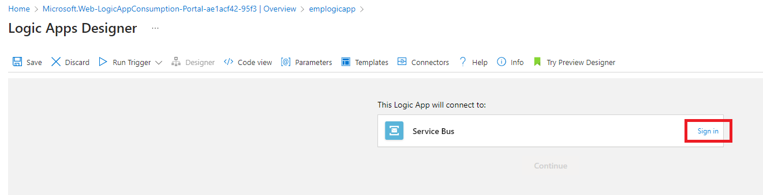
- Provide a name to this connection trigger, select ‘Access key’ for Authentication type and for Connection string, paste the Primary connection string of Service bus which you copied in previous step
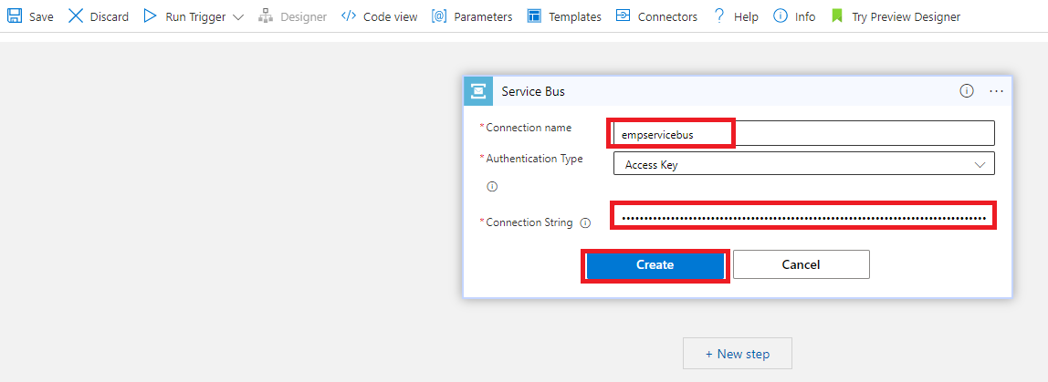
- Click on Create.
- Provide queue name which you created in service bus in previous steps and keep the default values for other properties.
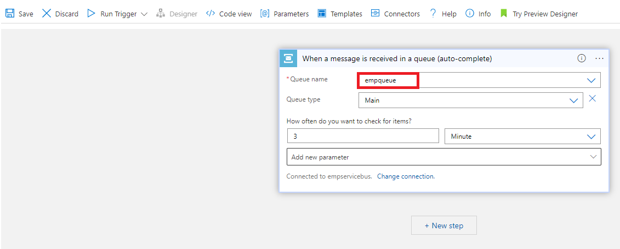
- Click on New Step, and search for ‘Outlook’, and click on ‘Send email (v2) (Outlook.com)’
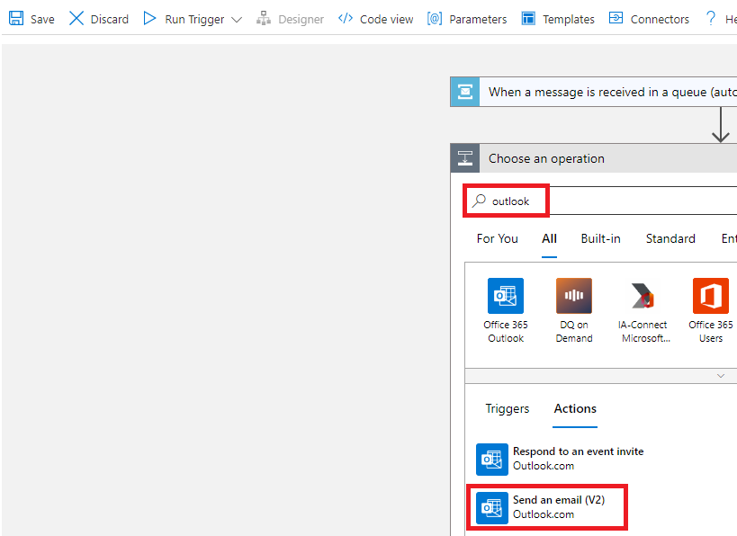
- Click on Sign in and sign into your personal outlook account
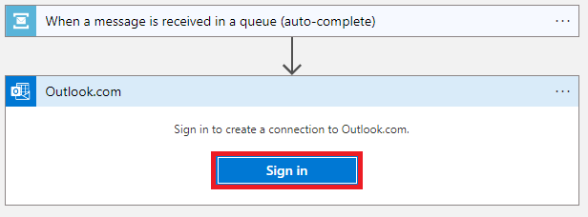
- For ‘To’, click on see more and select ‘Content’
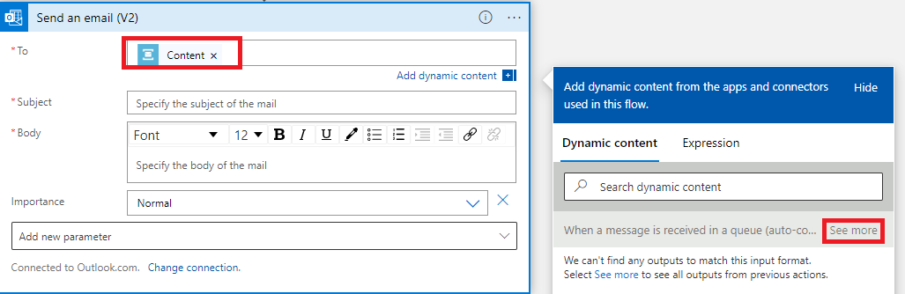

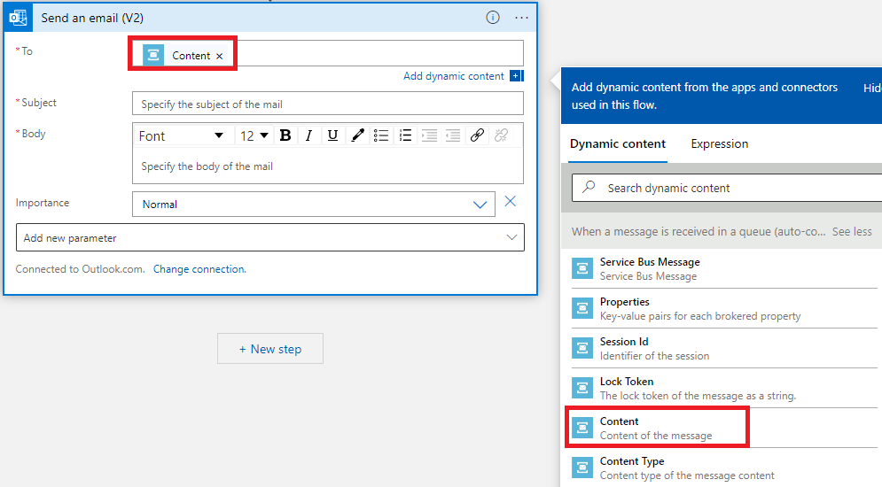
- For ‘Subject’ type ‘Welcome’
- For ‘Body’ type ‘Welcome to our Company!’
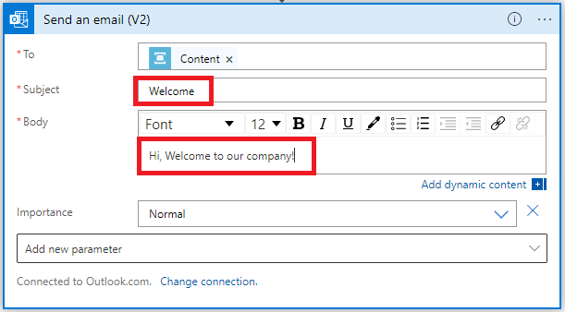
- Click on Save
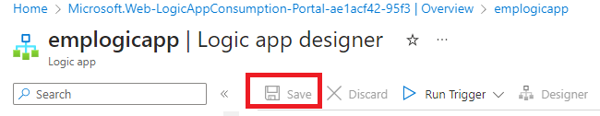
- Click on Run Trigger -> Run
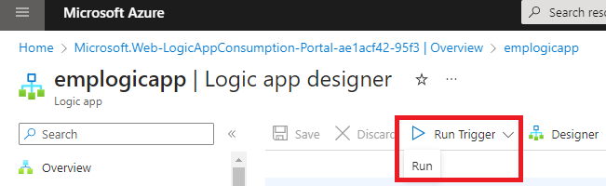
- In few minutes, a mail would be sent to the mail address provided when adding a new employee.
